1. Zero shot prompting

Prompt  
  


1. Single shot prompting  
     
   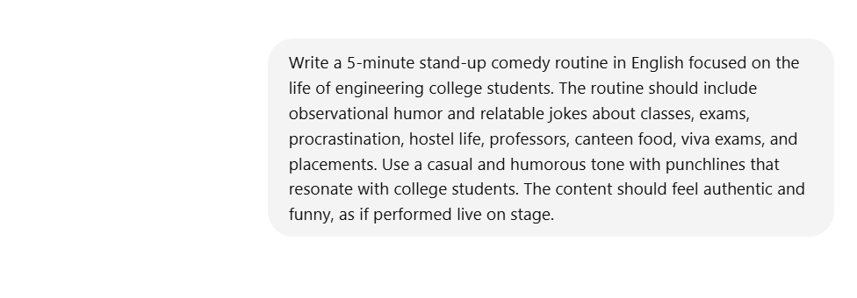
2. Few-shot prompting  
   Prompt  
     
   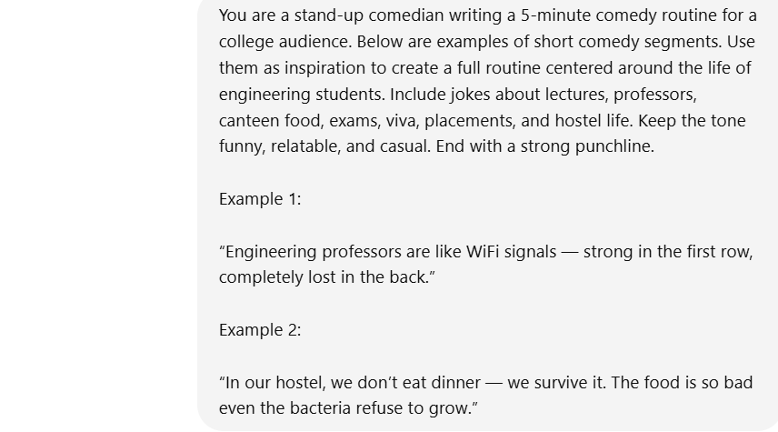
3. Negative prompting

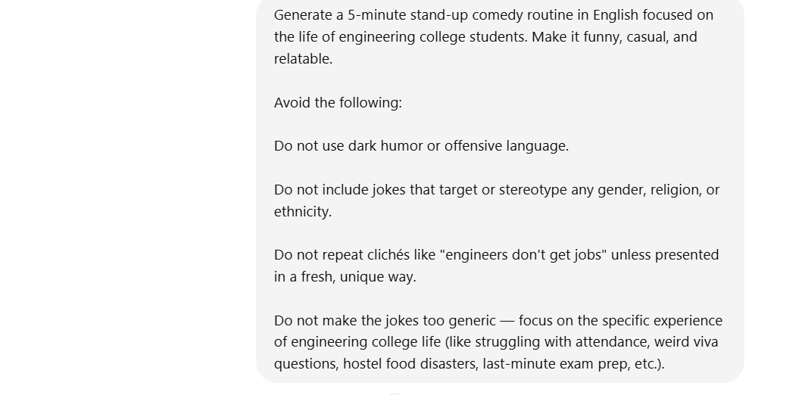

1. Iterative prompting

Step 1

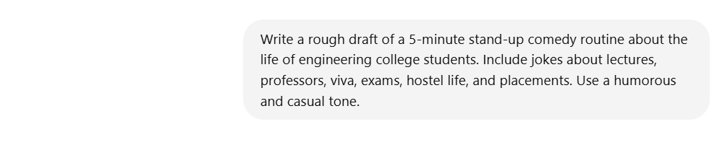  
  
Step 2



Chat link - https://chatgpt.com/share/6847e49f-4978-8004-ac51-1a672db03d4a